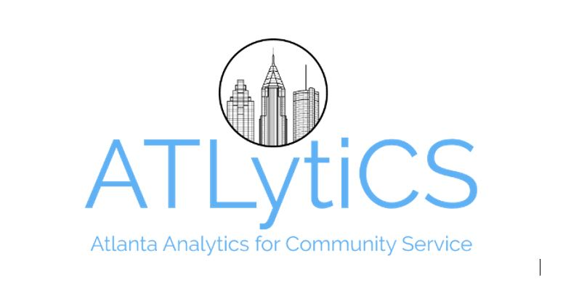

**Data for Hope 2018 / Data hackathon / Sponsored by 3sage / Hosted by Southern Data Science Conference**

Team: _____________________________________

|  |  |  |  |
| --- | --- | --- | --- |
| **Characteristic** | **Priority**  **(1 = high)** | **Score**  **(1 – 5)** | **Comment** |
| Addresses community concerns | 1 |  |  |
| Practical, scalable solution | 1 |  |  |
| Technically sound | 1 |  |  |
| Data management | 2 |  |  |
| Innovative solution | 2 |  |  |
| Communicated precisely, effectively | 3 |  |  |

Comments:

____________________________________________________________________________________________